HARIVIHAR INTEGRATED CHRONIC PAIN MANAGEMENT PROGRAM

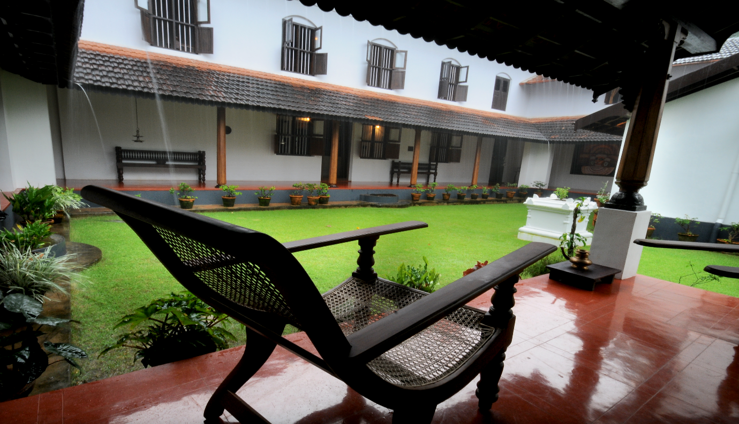

International Association for the Study of Pain defines pain as an unpleasant sensory and emotional experience associated with actual or potential tissue damage, or described in terms of such damage. Pain is classified into acute, sub-acute and chronic depending on the onset, duration and intensity.
Most of the pains are of chronic in nature lasting for more than six months, agonising and affecting the quality of life of a person physically and mentally. Most of the chronic pains are near constant with occasional flare-ups.
American Chronic Pain Association has graded chronic pain on a Quality of Life Scale between 0-10 where 0 represents pain which limits the person to bed and 10 is person leading a normal life despite the pain.
Pain in Ayurveda is termed either as shoola or ruja and is said to be caused by the Dosha of Vata in its pathological state. Ayurveda textbooks describe different types of pain as Shoola-piercing, Dagda-burning, Vedana-unexplainable discomfort etc. Most of the chronic pains come under the Vedana category.
Chronic Pain negatively affects the person and spreads its nagging irritating feel not only inside the person but also in his/her family, profession and his/her social life. Majority of the times chronic pains are set aside as back burners since they are mostly not life threatening.
Reality is chronic pains need to addressed as early as possible in time so as to prevent or minimize major damage to the physical, mental and social persona of the person. The program is designed and implemented following a thorough study of the condition and understanding the need for a comprehensive sustained management plan for chronic pain

Why Ayurveda for Chronic Pains?
A sizeable number of people suffering from chronic pains get along with the daily life activities. To do so they are dependent on topical applications like liniments, balms, sprays and similar options. These do provide temporary relief but do not address the underlying condition. Many rely on non steroidal anti inflammatory drugs or NSAIDS which are commonly referred to as pain killers. These medicines have a lot of side effects which prove detrimental on the long run and regular usage.
Benefits of Ayurveda for Chronic Pain
- Ayurveda medicines have minimal or no side effects if used properly and as prescribed
- Ayurveda relies on treating the underlying condition and correcting the pathology wherever possible
- Ayurveda therapies give sustained results and improve the health of the part affected
- Ayurveda pain management techniques and Marma therapies heal the person physically and mentally

Harivihar is a royal 170 year old heritage homestead located in Calicut, the northern city of Kerala . Harivihar has its core focus on Ayurveda and yoga wellness therapies.The unique feature of Harivihar is the seamless integration of modern medicine with traditional systems of medicine like Ayurveda and Marma. The Ayurveda Centre at Harivihar Heritage Homestead is one of the salient features of the property offering authentic result oriented wellness and curative Ayurveda programs managed by Sakalya Ayurveda group. The new initiative of Harivihar Heritage Homestead is the INTEGRATED CHRONIC PAIN MANAGEMANT PROGRAM. The program is designed and implemented by a group of specialists who are renowned and experienced in their respective areas of clinical expertise. More details are always provided on direct enquiries through mail or call.

HARIVIHAR INTEGRATED CHRONIC PAIN MANAGEMENT TEAM:

Consultants
- Dr. Manojkumar PC ,B.A.M.S, Chief Consultant Sakalya Ayurveda
- Discipline: Ayurveda
- Experience: More than 25 years
- Area of Expertise: Spinal Disorders, Joint Disorders, Neck Pain, Back Pain, Neurological Disorders

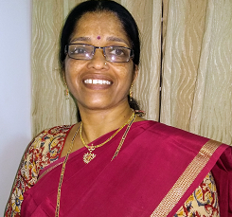
- Dr. Valsaladevi K.B.A.M.S,F.A.G.E,Y.I.C, Senior Consultant Sakalya Ayurveda
- Discipline: Ayurveda
- Experience: More than 25 years
- Area of Expertise: Marma Therapy, Clinical Yoga, Healthy Diet

- Mr Gopalakrishnan (Gopalji) 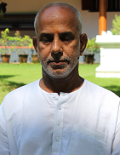
- Discipline-Yoga (Sivananda)
- Experience- more than 25 years
- Area of expertise- yoga ,meditation ,pranayama

Advisors

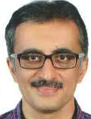
- Dr. Srikumar G ,M.B.B.S,M.D,D.N.B,D.M(Neurology),Managing director
- Discipline: Allopathy
- Experience: More than 35 years
- Area of Expertise: Neurology
- Dr. Renjith Kumar B.A.M.S,M.B.B.S,M.D
- Discipline: Ayurveda and Allopathy
- Experience: More than 30 years
- Area of Expertise: Acute and Chronic Pain Management ,Anaesthesiology

HARIVIHAR INTEGRATED CHRONIC PAIN MANAGEMENT PROGRAM
Diseases Managed:
- Migraine and related Headaches
- Neck Pain and Back Pain
- Knee Pain
- Fibromyalgia
- Frozen shoulder
- Arthritis
- Lumbago
- Disc related problems
- Postural pains
- Trigeminal neuralgias
- Cephalalgias
- Neuropathic pains etc
Highlight of the Program: The perfect rarest of the rare combination of the medical panel
Harivihar Integrated Chronic Pain Management Program is designed to manage the Vedana category of pains which come under the grading of 5-10 on the Quality of Life Scale by American Chronic Pain Association. The program intends to
- Elicit the reasons for the pain through
    - Detailed consultation
    - Investigation
    - Counselling
    - Panel discussion of the doctors team
- Reduce the pain through Ayurveda pain management techniques of
    - Internal Ayurveda medicines
    - Ayurveda external pain management techniques like Lepam, Pichu, Sthanika Vasthy, Bandham, Dhara, Kizhi, Vasthy, etc.
- Application of manipulation techniques like
    - Traction
    - Marma Therapy
    - Acupressure
- Customized Yoga Asanas to improve joint flexibility and reduce muscle stiffness
- Personalized Meditation to de-stress the mind
- Eliminate or mitigate the reason through
    - Special diets for the condition
    - Lifestyle counselling
    - Take home exercises/yoga
    - Psychological counselling
- Continuous follow up and review sessions through direct consultation or online discussions with the members of the expert team
The ambience, atmosphere and hospitality do have an important role in the recovery process from the chronic pains. At Harivihar the care and stay is unique and relaxing with
- Sprawling antique heritage homely ambience
- De-stressing lawn and natural pool side
- Re-assuring homely atmosphere
- Attentive caring staff
- Invigorating cultural activities
- Tasty ,healthy and simple vegetarian food
For more details please feel free to contact us at harivihar@harivihar.com
www.harivihar.com
Whatsapp us at +91 9847072203

